**Day 4 Assignment**

--1)List all customers and the products they ordered with the order date. (Inner join)

--Tables used: customers, orders, order_details, products

--Output should have below columns:companyname AS customer,orderid,productname,quantity,orderdate

SELECT

SELECT

cp.company_name AS customers,

oe.order_id,

pr.product_name,

od.quantity,

oe.order_date

FROM

customers cp

INNER JOIN

orders oe ON cp.customer_id = oe.customer_id

INNER JOIN

order_details od ON oe.order_id = od.order_id

INNER JOIN

products pr ON od.product_id = pr.product_id

ORDER BY

cp.company_name, oe.order_date;

Output - This output is with ORDER BY details with alphabetically and date wise

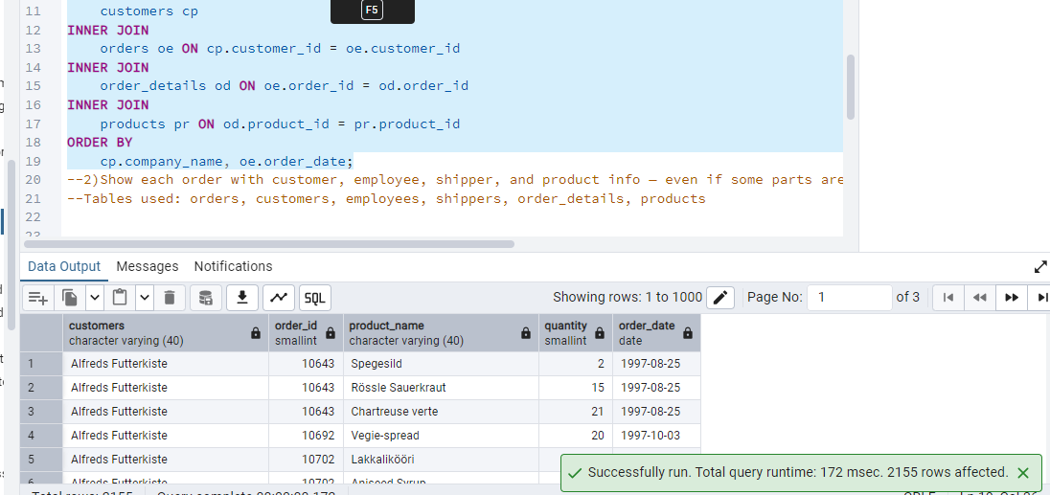

SELECT

cp.company_name AS customers,

oe.order_id,

pr.product_name,

od.quantity,

oe.order_date

FROM

customers cp

INNER JOIN

orders oe ON cp.customer_id = oe.customer_id

INNER JOIN

order_details od ON oe.order_id = od.order_id

INNER JOIN

products pr ON od.product_id = pr.product_id;

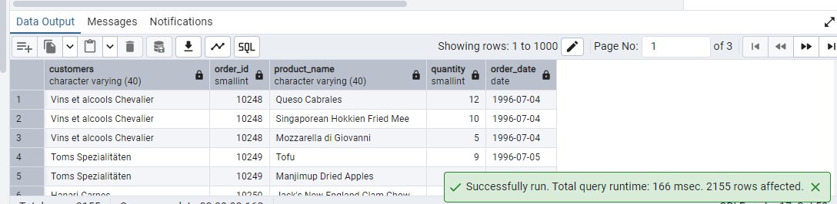

--2)Show each order with customer, employee, shipper, and product info — even if some parts are missing. (Left Join)

--Tables used: orders, customers, employees, shippers, order_details, products

SELECT

oe.order_id,

cp.company_name AS customers,

(em.first_name || ' ' || em.last_name) AS employees,

sh.company_name AS shippers,

pr.product_name,

od.quantity,

oe.order_date

FROM

orders oe

LEFT JOIN

customers cp ON oe.customer_id = cp.customer_id

LEFT JOIN

employees em ON oe.employee_id = em.employee_id

LEFT JOIN

shippers sh ON oe.ship_via = sh.shipper_id

LEFT JOIN

order_details od ON oe.order_id = od.order_id

LEFT JOIN

products pr ON od.product_id = pr.product_id;

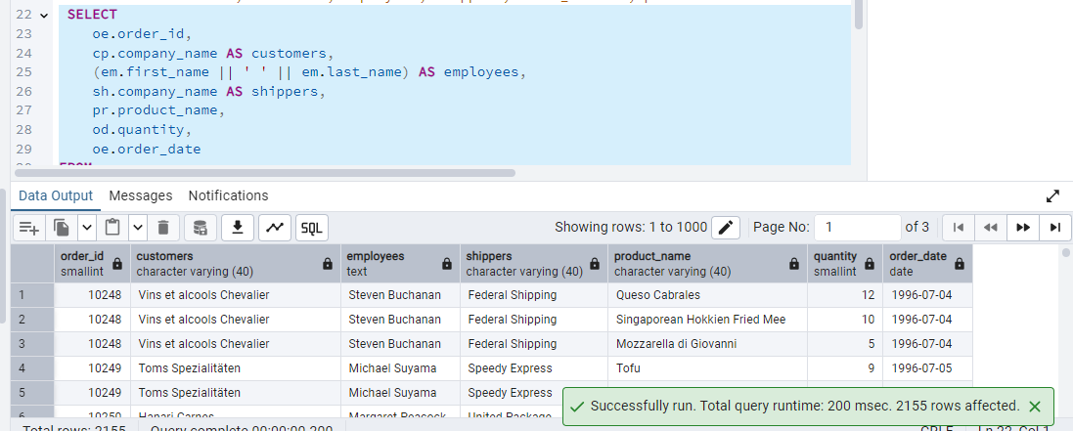

--3)Show all order details and products (include all products even if they were never ordered). (Right Join)

--Tables used: order_details, products Output should have below columns:orderid,productid,quantity,productname

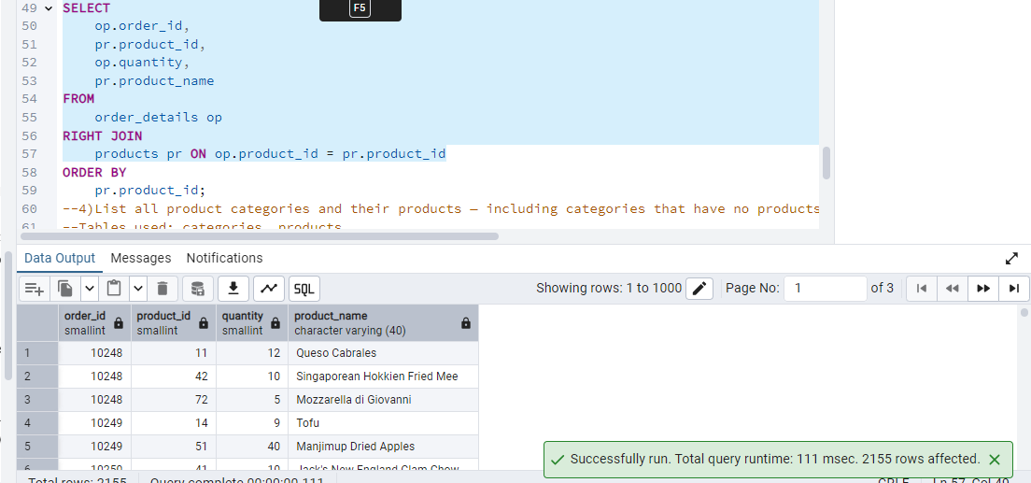

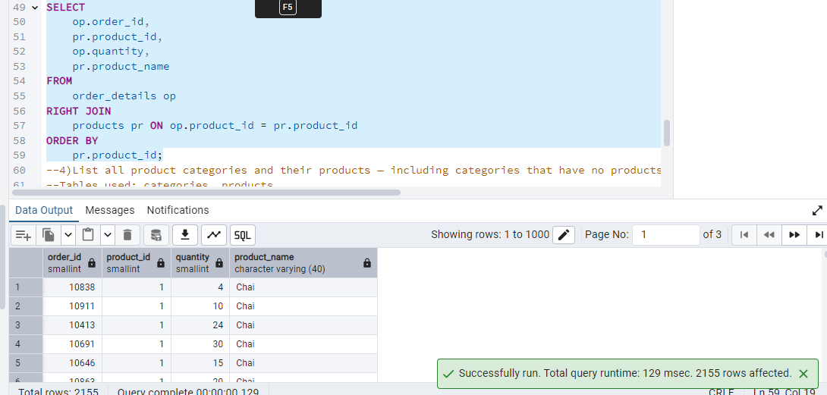

--4)List all product categories and their products — including categories that have no products, and products that are not assigned to any category.(Outer Join)

--Tables used: categories, products

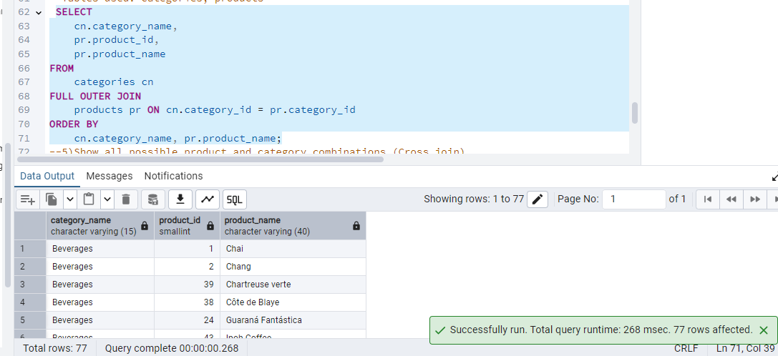

--5)Show all possible product and category combinations (Cross join).

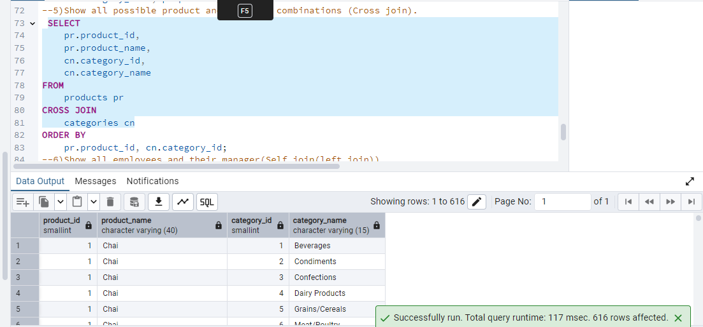

OR

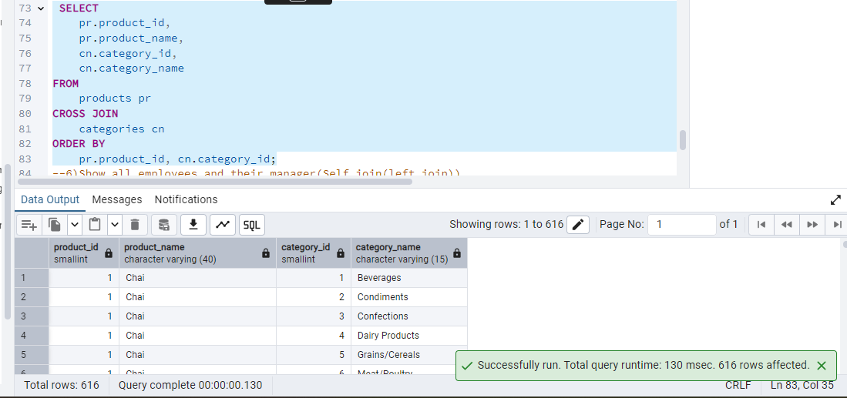

--6)Show all employees and their manager(Self join(left join))

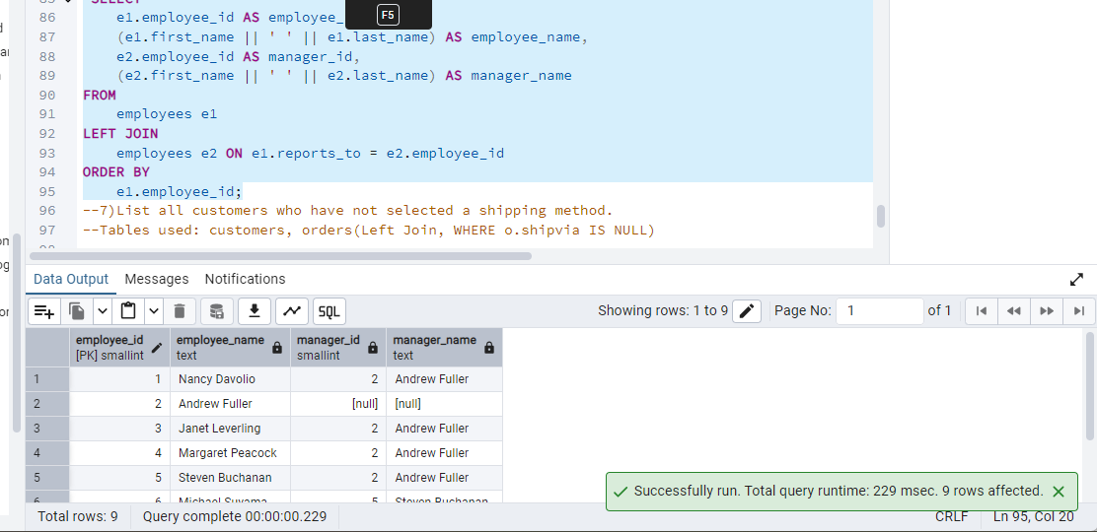

--7)List all customers who have not selected a shipping method.

--Tables used: customers, orders(Left Join, WHERE o.shipvia IS NULL)

